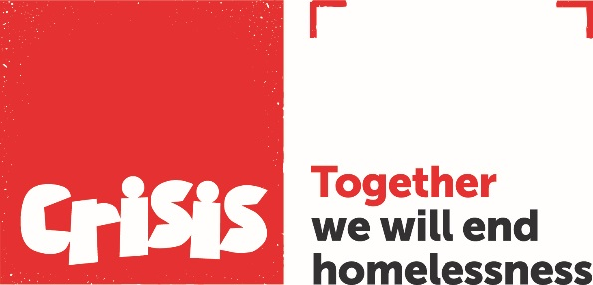
EEA National Experts by Experience Panel
Application Form

Thank you very much for your interest in joining the Experts by Experience panel for our campaign to ensure EEA nationals do not become homeless because of their immigration status.

All the information you provide on this form is confidential and will not be passed on to a third party. Crisis complies fully with current Data Protection legislation.

Please tell us about yourself

Title |  | Forename(s)
Surname |  |  |  | DOB
Address

Post code
Telephone
Email
Emergency contact:
(Name, relationship to you & contact number)

If you are a Crisis member, please tell us which Skylight you at.

If you use the services of another organisation, please tell us which one.

Please tell us why you would like to get involved (you can tick more than one box)

I want to help end homelessness |  | I’m interested in meeting new people
To make myself more employable |  | Sharing my skills and experience to help others
Give something back in my community |  | I want to develop new skills
To keep myself busy |  | Something enjoyable to do with my time
I was asked by a friend |  | I want to make a difference
To help me in my journey |  | I believe in this cause
I’ve been homeless and want to give back |  | I’d rather get involved than give money

Please tell us a little more about you and what skills and qualities you feel make you suitable for this role and why you are committed to ending homelessness (if we receive a number of applications for a role, we use this information for shortlisting. Refer to the role description, in particular the skills and experience required)

Please confirm that you are an EEA national living in the UK before 31 December 2020

Y/N (delete as appropriate)

What is your first language?

Will you need translation support for the interview process? Y/N (delete as applicable).

References

Please provide us with the details of someone we may contact as referee, to comment on your suitability for this role. This should be your lead worker if you are a Crisis member, or your key worker if you are connected with another service.

If you are currently not a Crisis member, this might be your line manager if employed at Crisis, or someone who has know you for at least six months, though not a family member.

Referee
Name

Email
Telephone
Role
Skylight or Organisation

Please return your completed application form to livedexperience.campaigns@crisis.org.uk by 18th February.

